**AWS CodeDeploy**

**Steps to work with Code Deploy**

1. First we create EC2 system and keep it ready to work with AWS Code Deploy
2. Launch and Amazon Linux 2 AMI ( in same region where your AWS Code Deploy and CodeCommit, S3 Bucket has been selected/created )

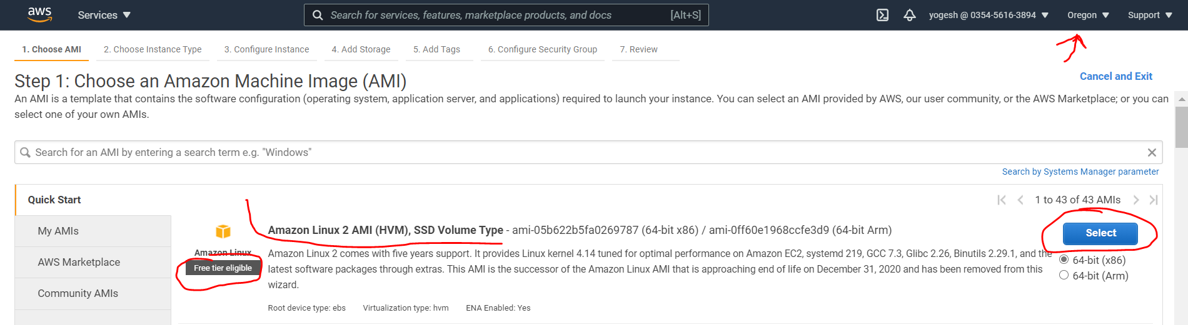

1. On below screen , before selection of IAM role , we have to create an IAM Role for following reasons :
   1. The role will allow EC2 instance to fetch the code (artifacts) from S3 bucket

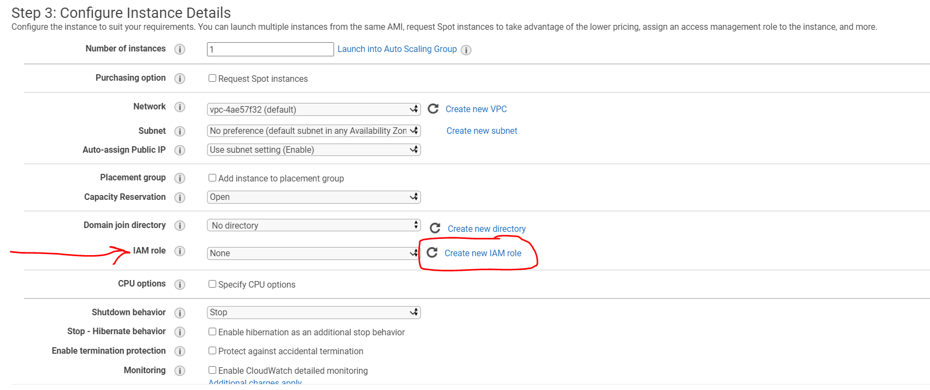

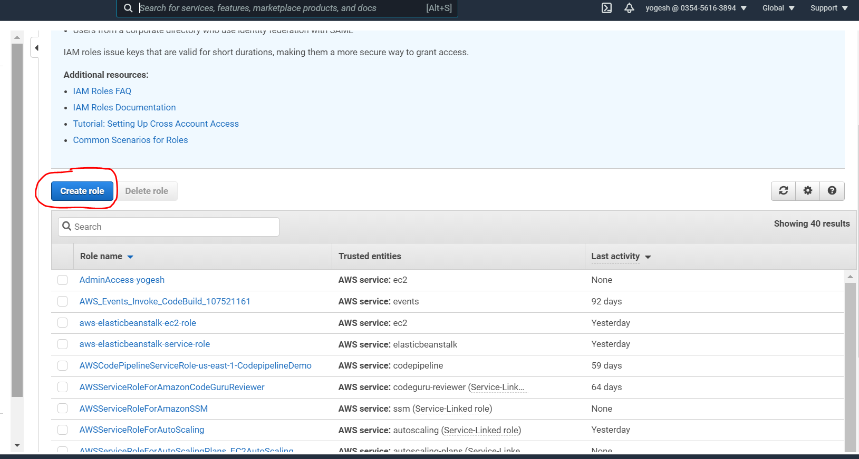

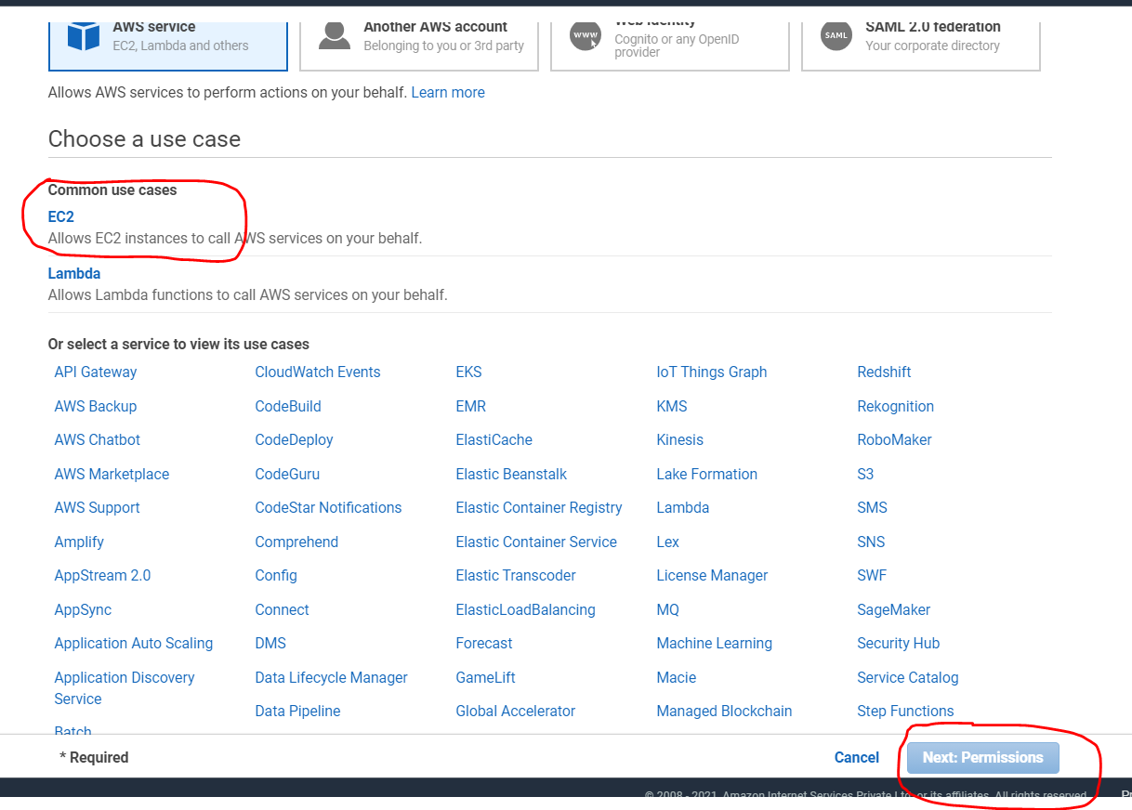

Add **S3 Read Only Access**

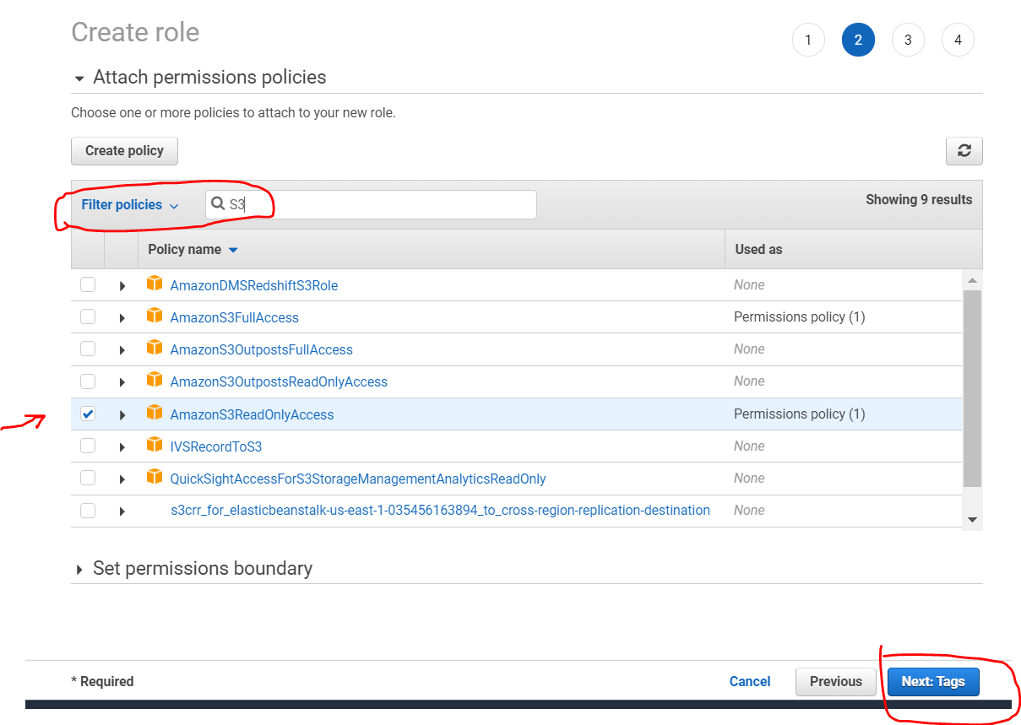

Give name to your role like below , the name could be anything

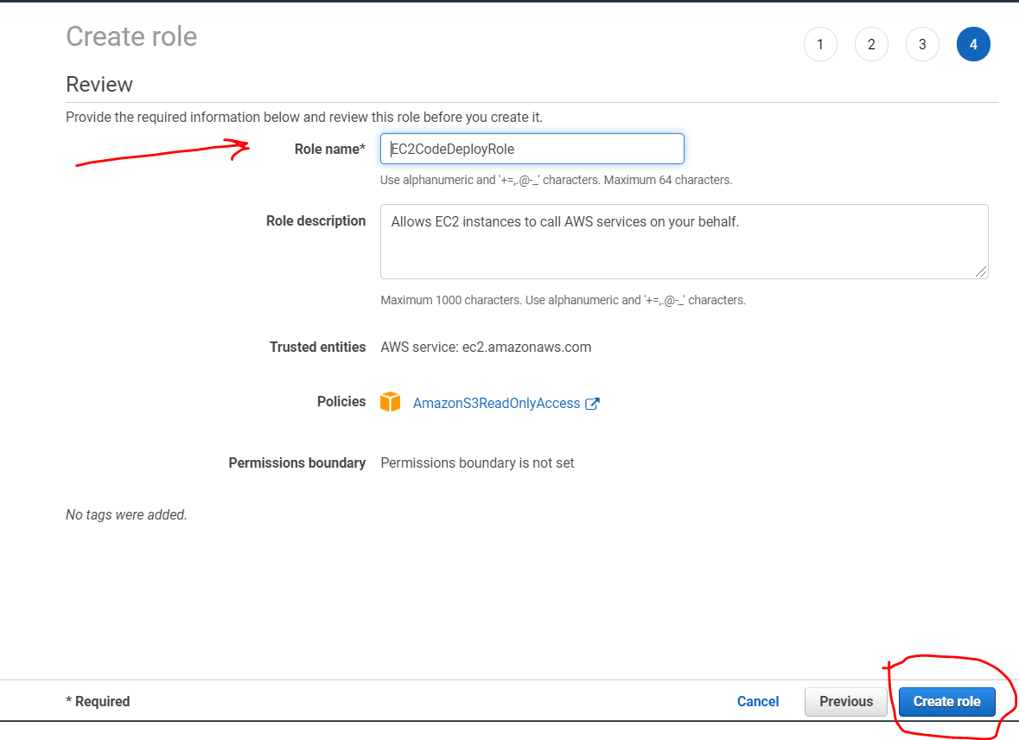

Since the role has been created , now go back to your EC2 instance launch screen and select this IAM role there, like below

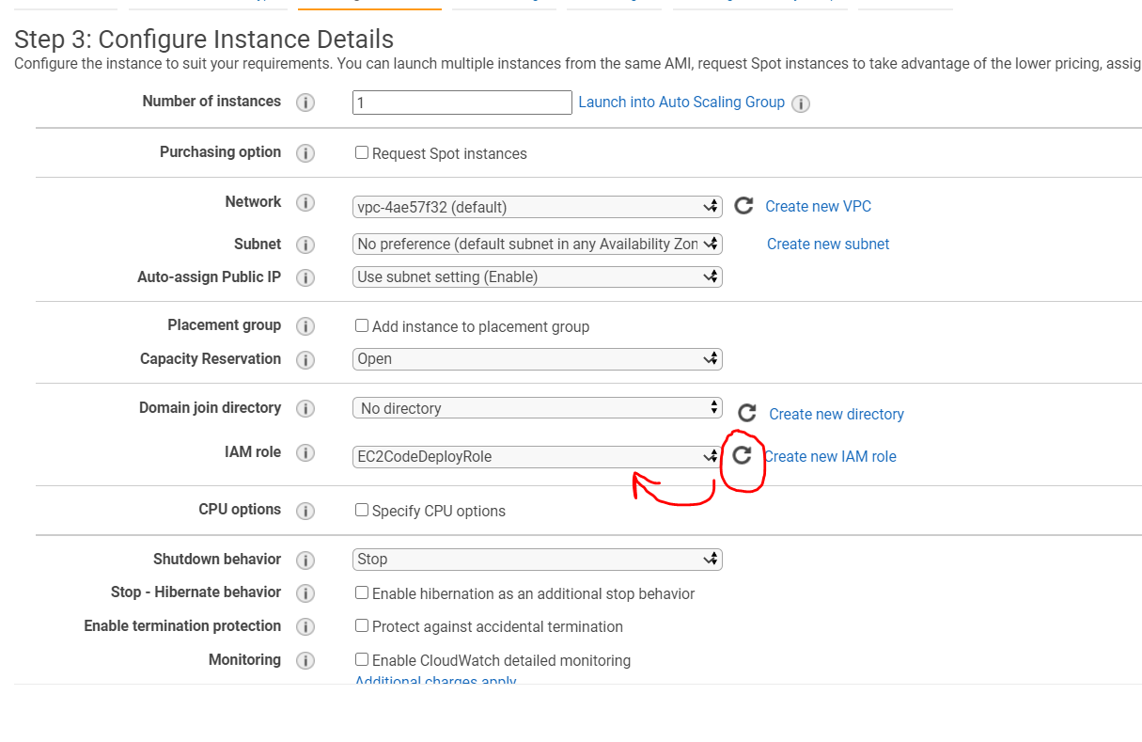

Launch instance ( Keep the key pair downloaded on your system )

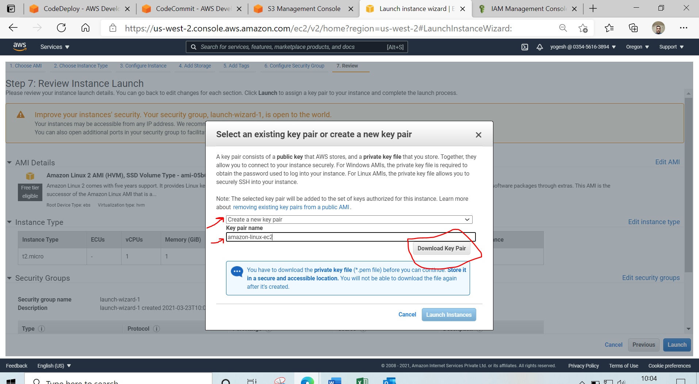

Now , we will connect with our EC2 instance and perform the configuration , which is relevant to CodeDeploy

* Install Code Deploy agent on your EC2 instance

#!/bin/bash

sudo yum update -y

sudo yum install -y ruby wget

wget https://aws-codedeploy-eu-west-1.s3.eu-west-1.amazonaws.com/latest/install

chmod +x ./install

sudo ./install auto

sudo service codedeploy-agent status

You have successfully installed CodeDeploy agent on your system and have given an IAM role to your EC2 instance to read the artifacts from S3 bucket.

Now, give a tag to your EC2 instance , so that while performing CODEDEPLOY, the code deploy should be able to identify the system where the deployment has to be performed.

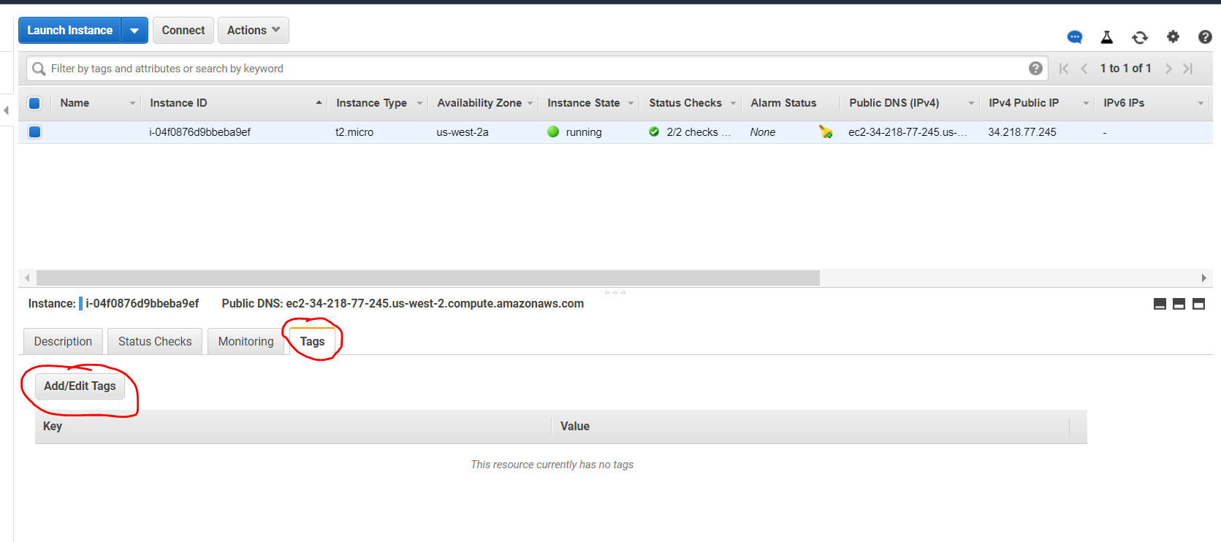

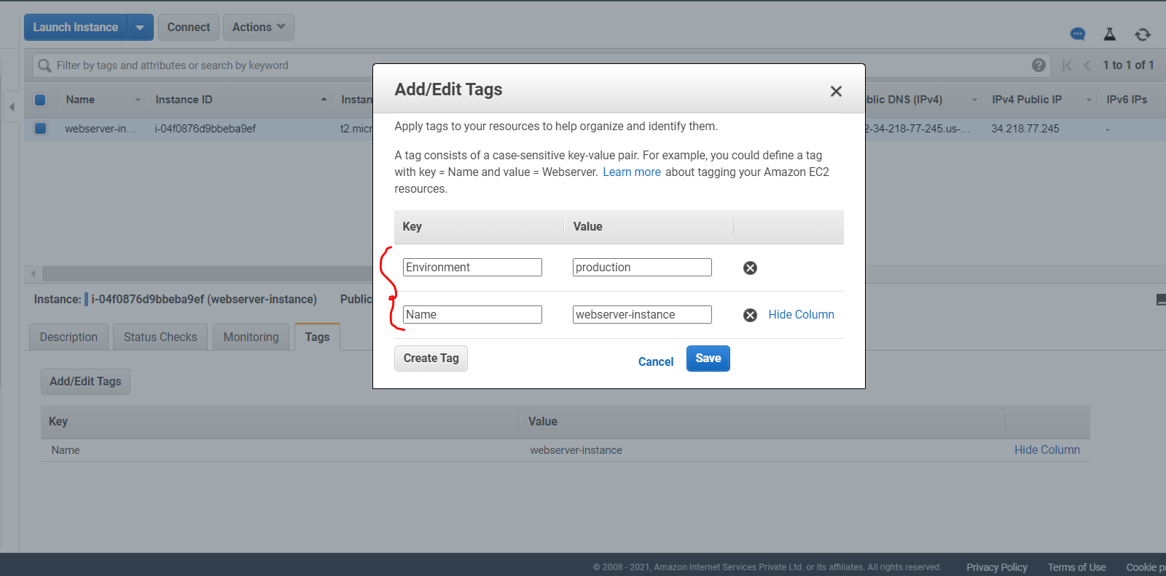

Now, we will create application in Code Deploy

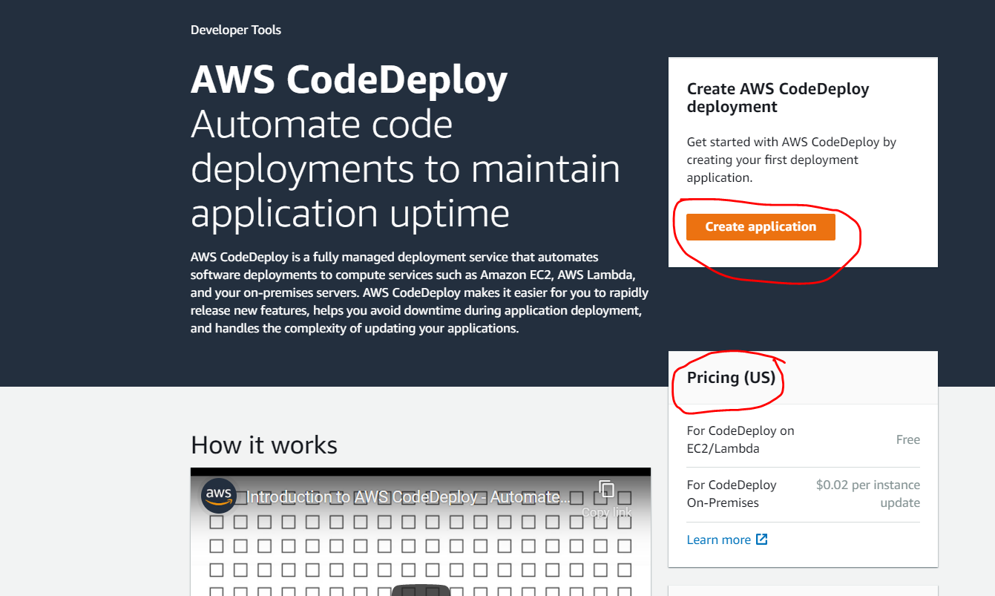

Now , give any name to your application and select the compute platform as below:

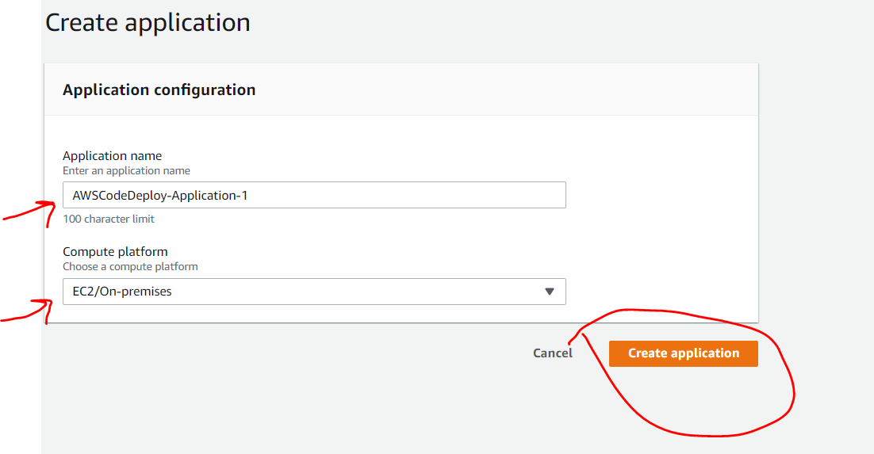

Now , you have to create “DEPLOYMENT GROUP”

Note – The deployment group represents , a set of EC2 instance on which , you want to deploy the application.

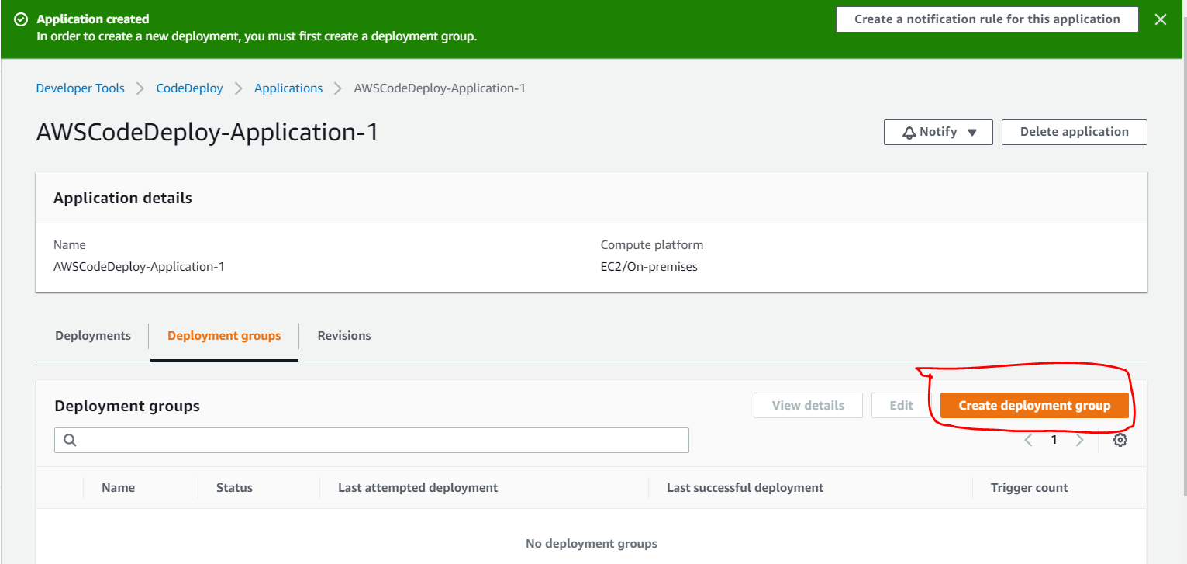

We can give any name to our deployment group like below and we have to create a service role

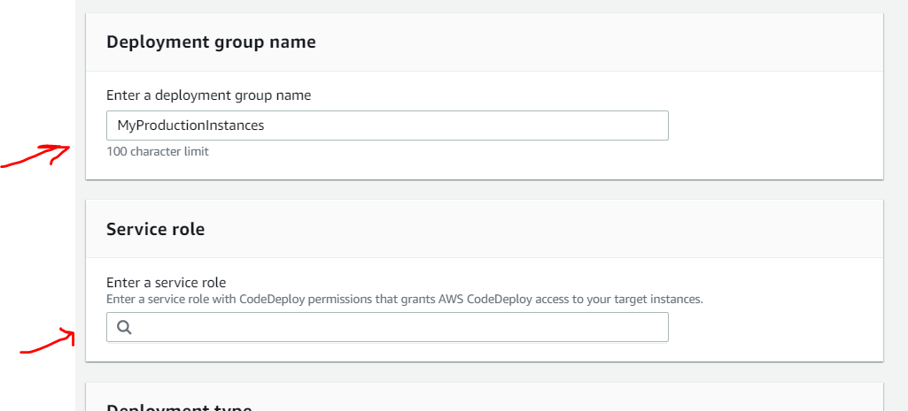

The service role can be created from IAM, so open a separate window and create a service role from there:

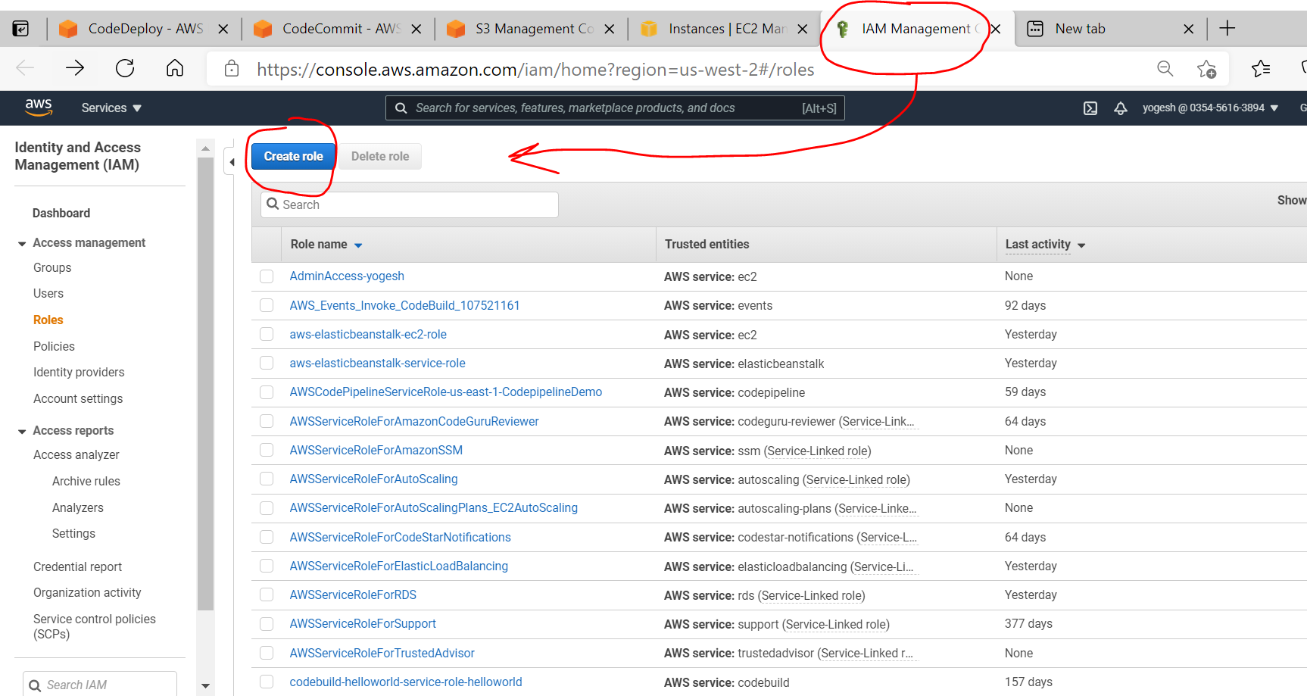

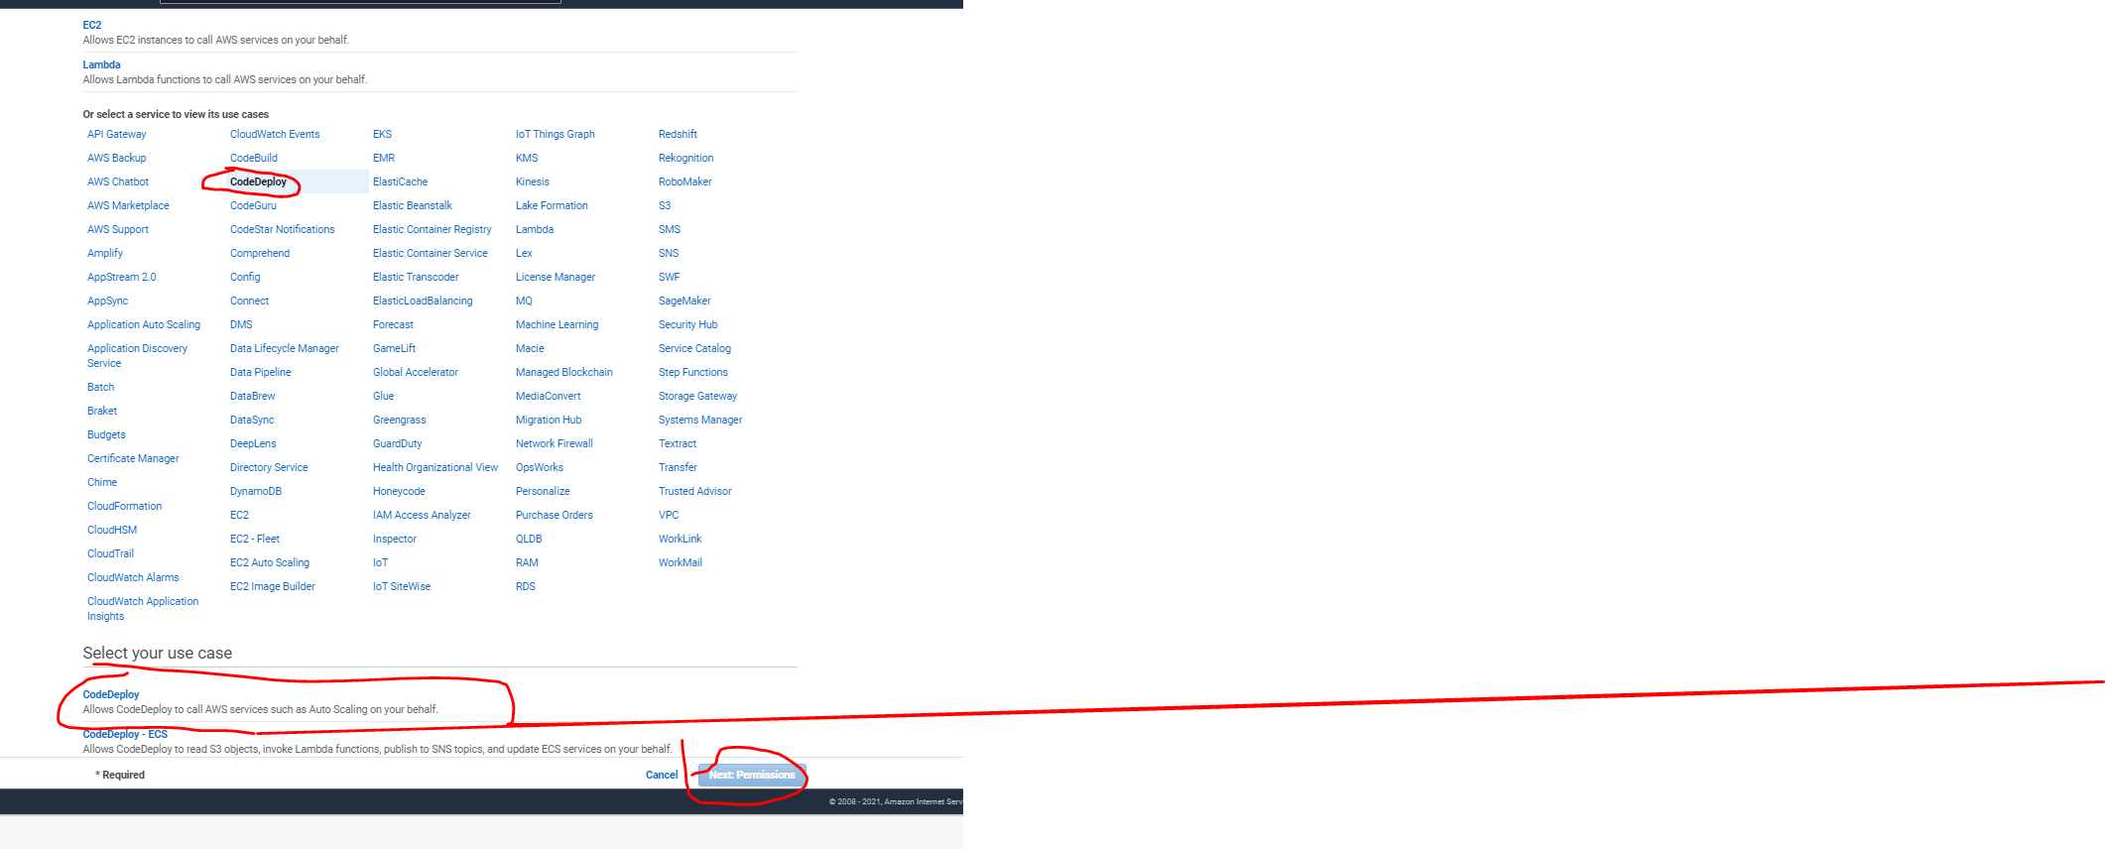

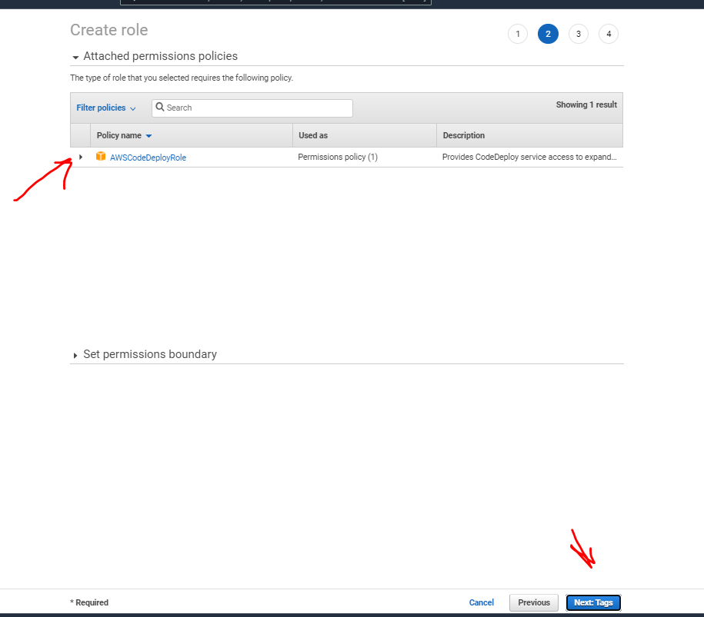

Now, give name to your role , you can give any name to your role

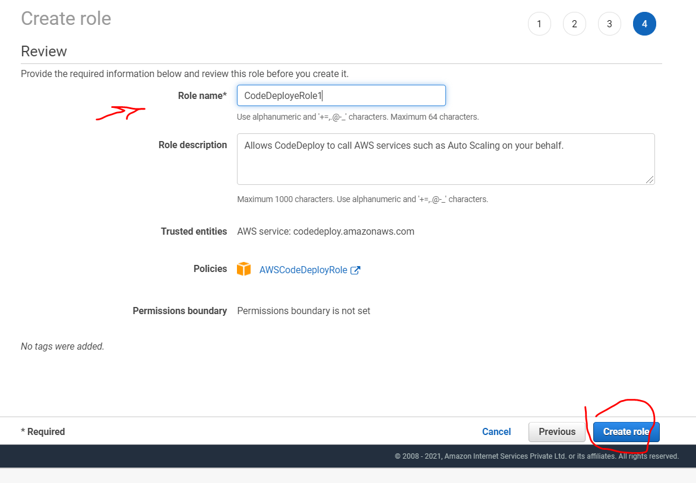

Refresh your Code Deploy page and check that your service role is appearing there, you might have to give deployment group name again

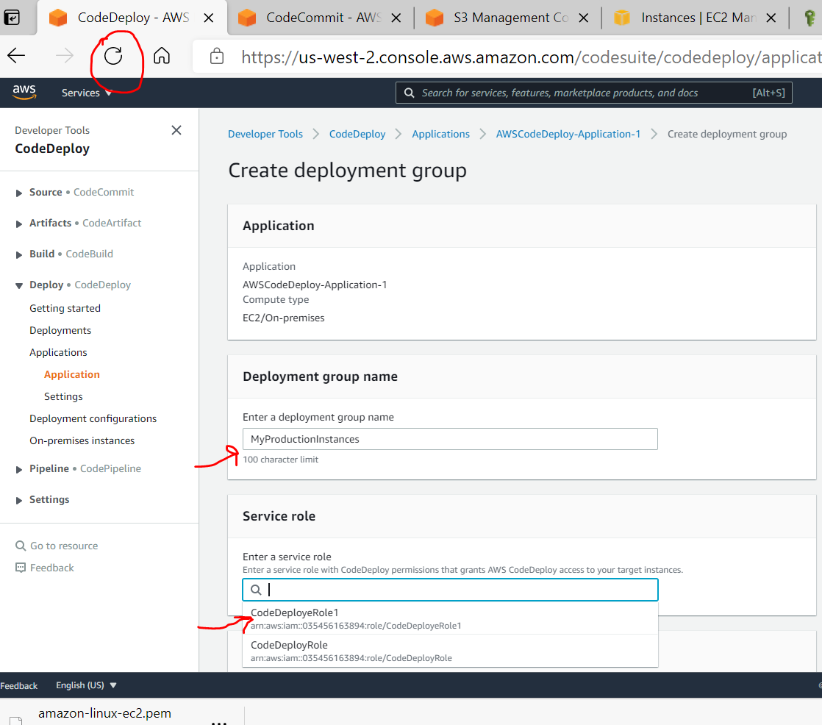

Now , we select “Deployment Type”

* We will select In-Place (this will bring down the environment for making changes and then up it again)
* In Environment Configuration, we will select EC2 instance.

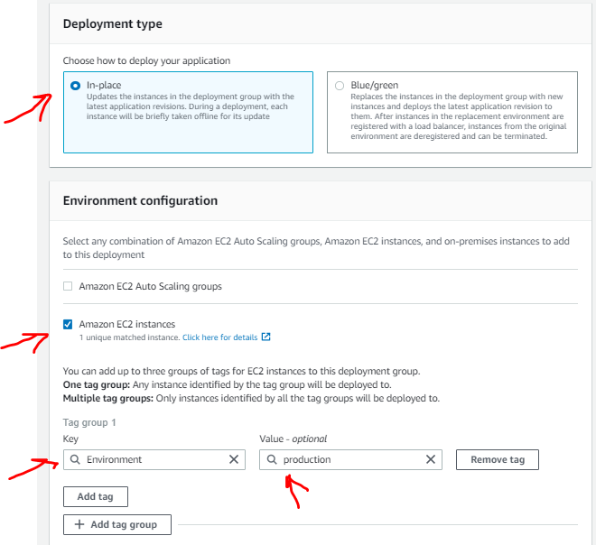

Select “Never” , because we have already installed code deploy agent.

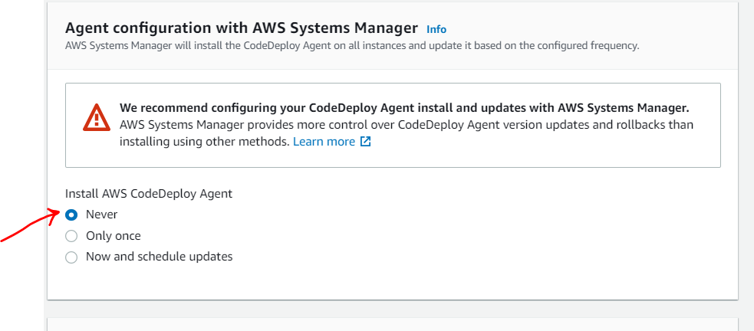

Mention deployment settings

* We will uncheck the load balancing , because we have not created any load balancer and keep the default value of deployment configuration ( All at once ) , although this could be selected different as per your requirement.

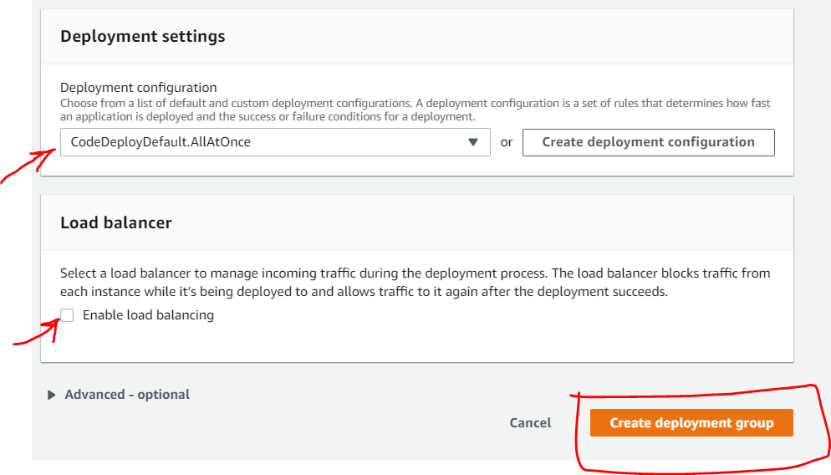

After deployment group, we will now create “Deployment”

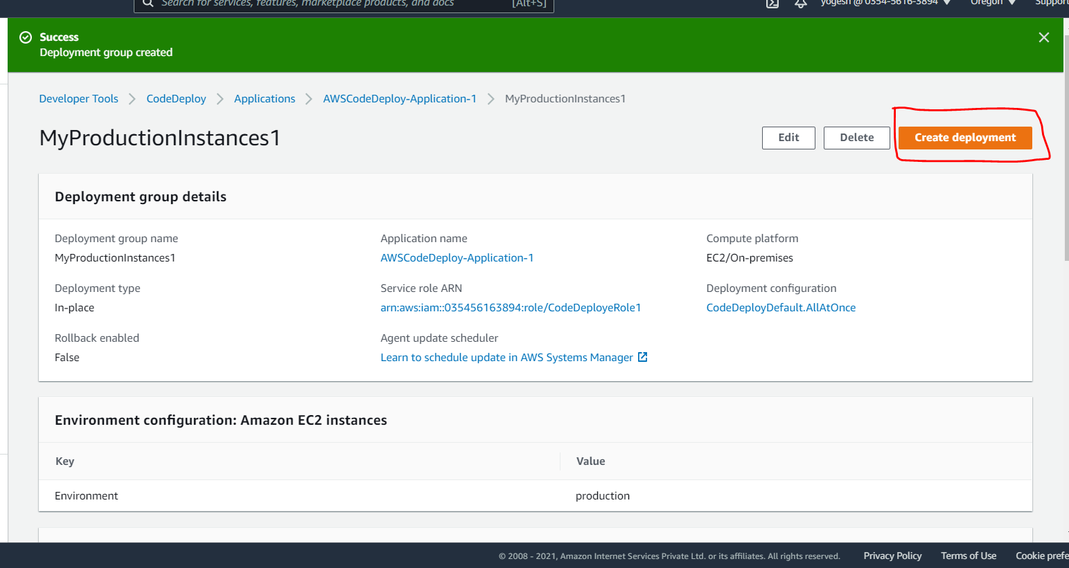

After clicking on Create Deployment, you will see below screen

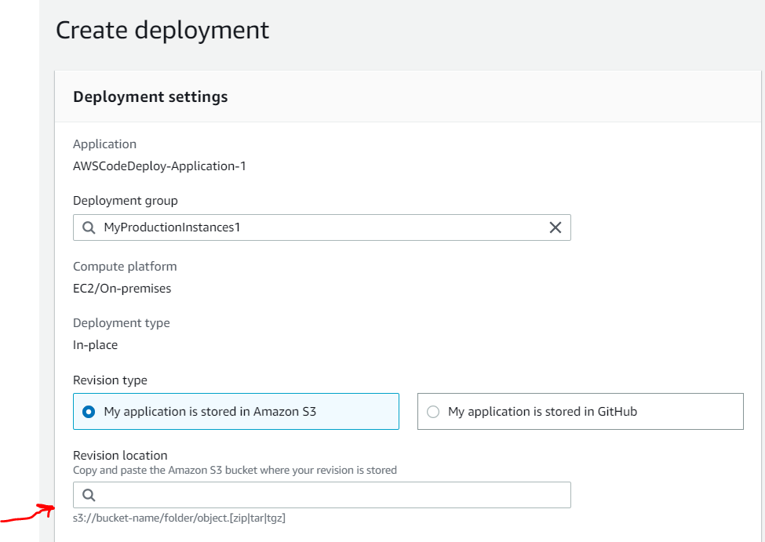

Here it is asking to mention S3 bucket where your application files are stored and S3 bucket versioning is enabled.

To fulfil this requirement, follow below steps:

1. Open command prompt and configure AWS credentials using AWS Configure command ( You should be having aws access key and secret and this you will get from your IAM user )

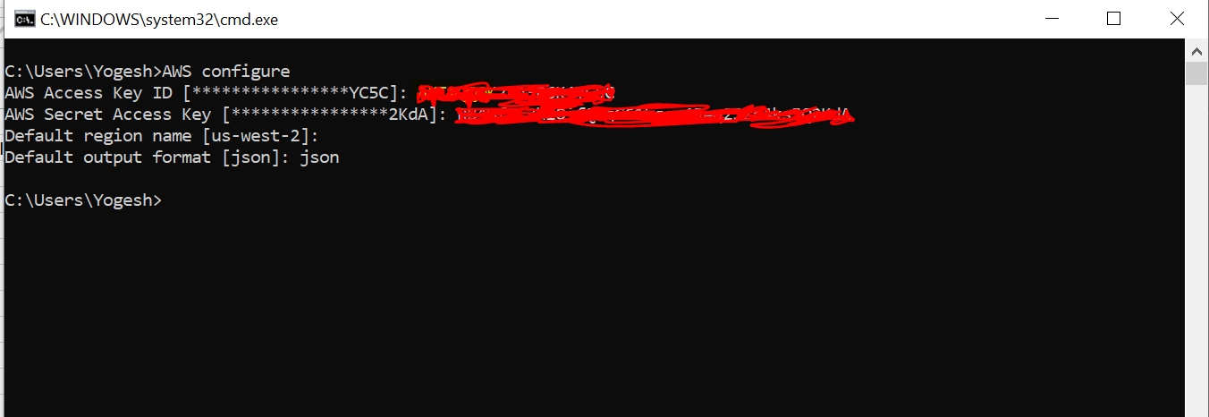

# you have to create a bucket and enable versioning. Please mention the region where your EC2 instance is created ( If your bucket is already created then you can enable versioning from GUI also and can skip below command )

**aws s3 mb s3://devops-learning-nci --region eu-west-2**

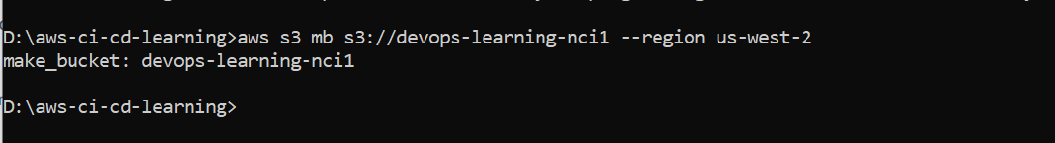

# Enable versioning on this bucket

**aws s3api put-bucket-versioning --bucket devops-learning-nci1 --versioning-configuration Status=Enabled --region us-west-2**

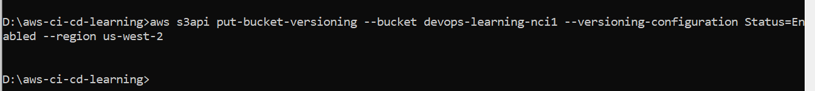

In below screenshot, we are in a directory where our application files are kept

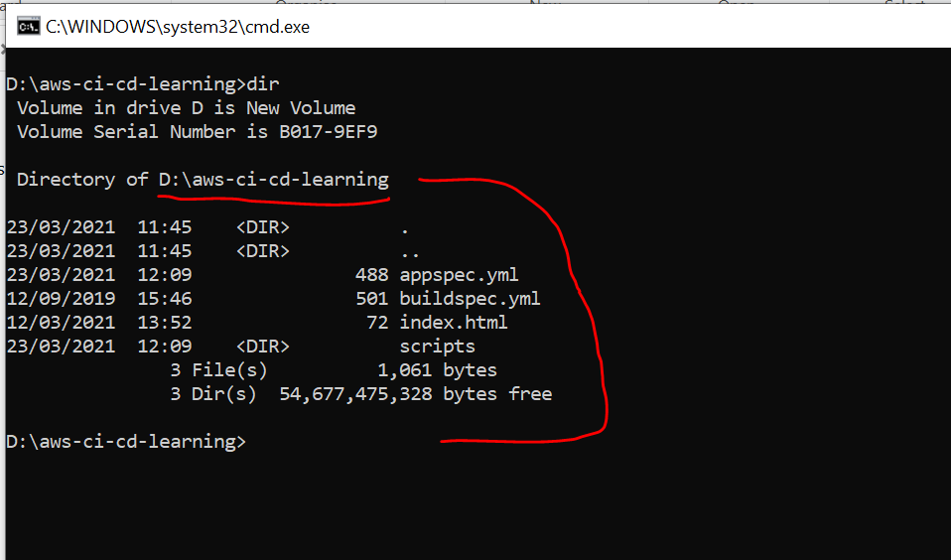

Note – The appspec.yml file should be at root level.

# Store the files on S3 , please mention your **application name (i.e. Code Deploy Application)** as you have given on GUI and relevant path on S3 bucket wherever you want to upload application files in **zip format**

# You should execute below command from a directory on your system where your application files are kept

**aws deploy push --application-name AWSCodeDeploy-Application-1 --s3-location s3://devops-learning-nci1/AWSCodeDeploy-Application-1/app.zip --ignore-hidden-files --region us-west-2**

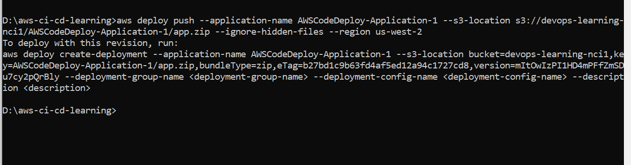

Now, check you S3 bucket , it will show zip file under application name folder

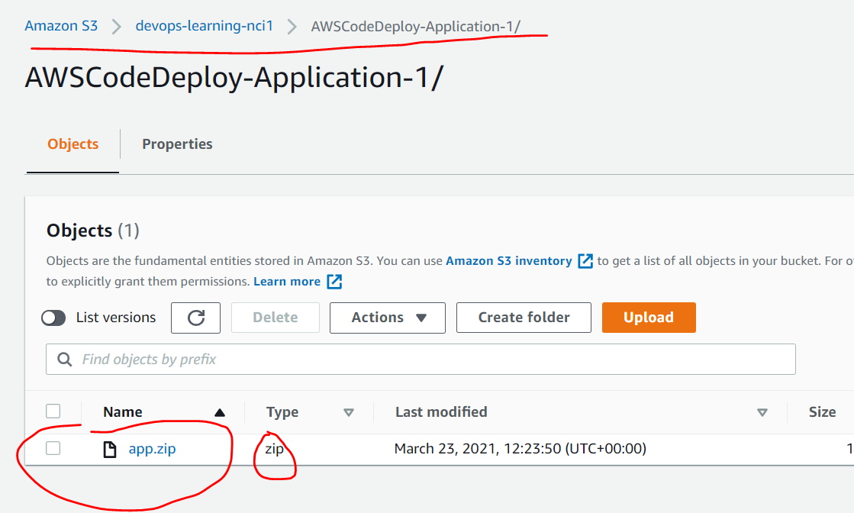

Now, before continuing with Code Deploy, please enable the port 80 on your EC2 instance

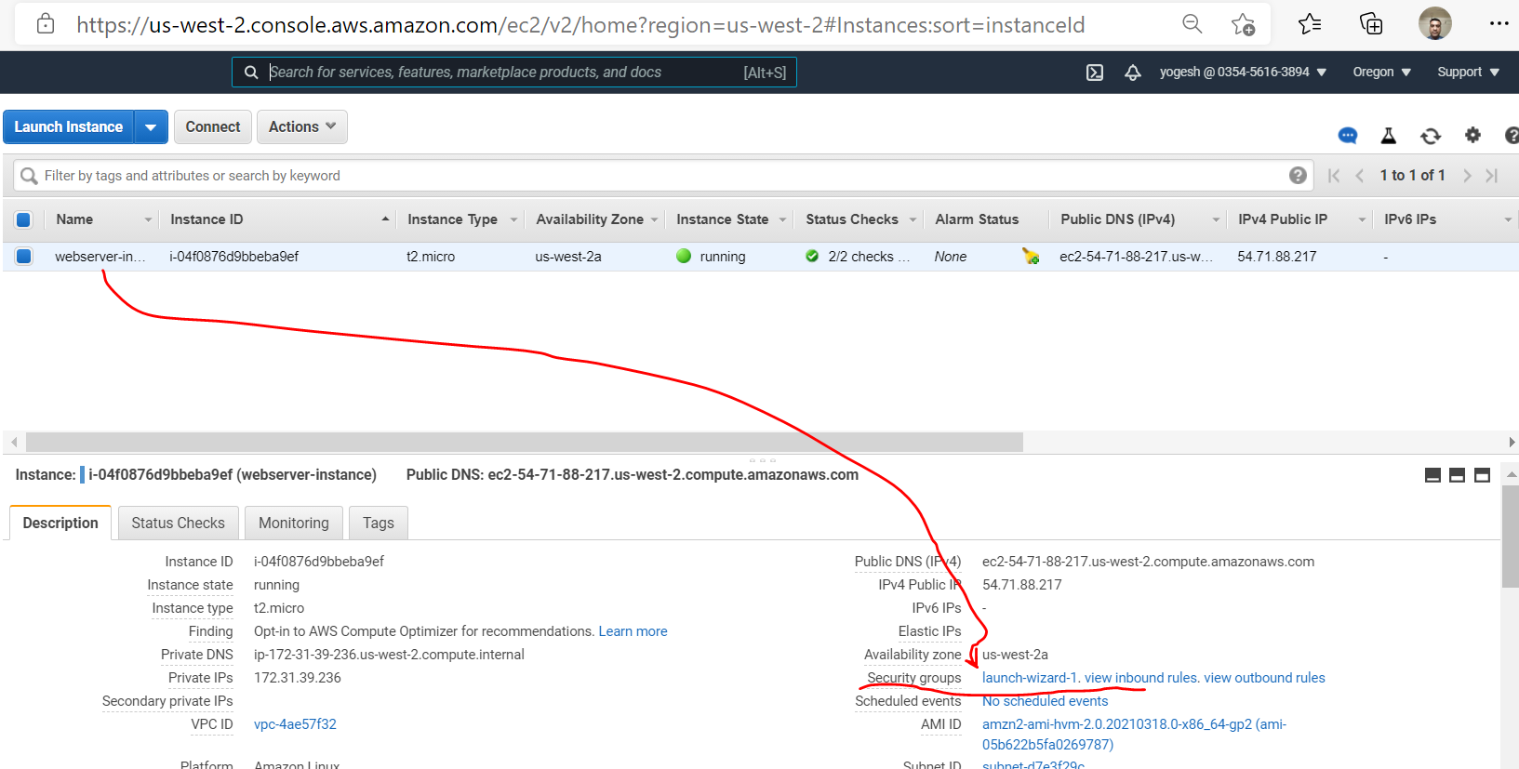

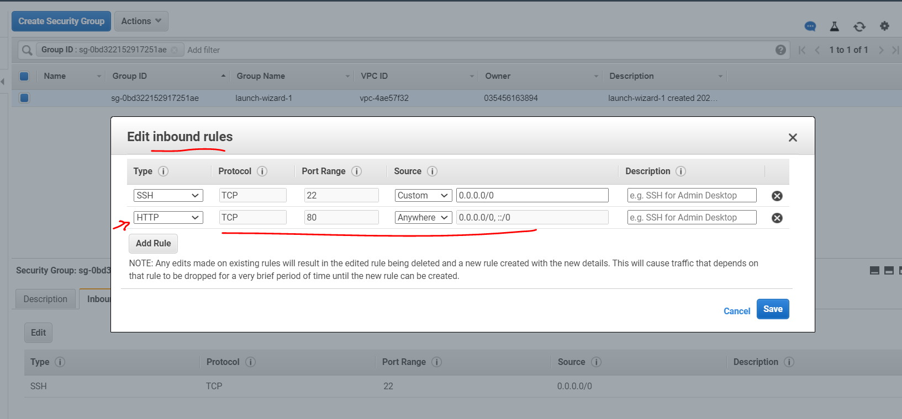

Now,

Refresh your code deploy ( create deployment ) page and check the revision location as shown below , it will show you the s3 bucket

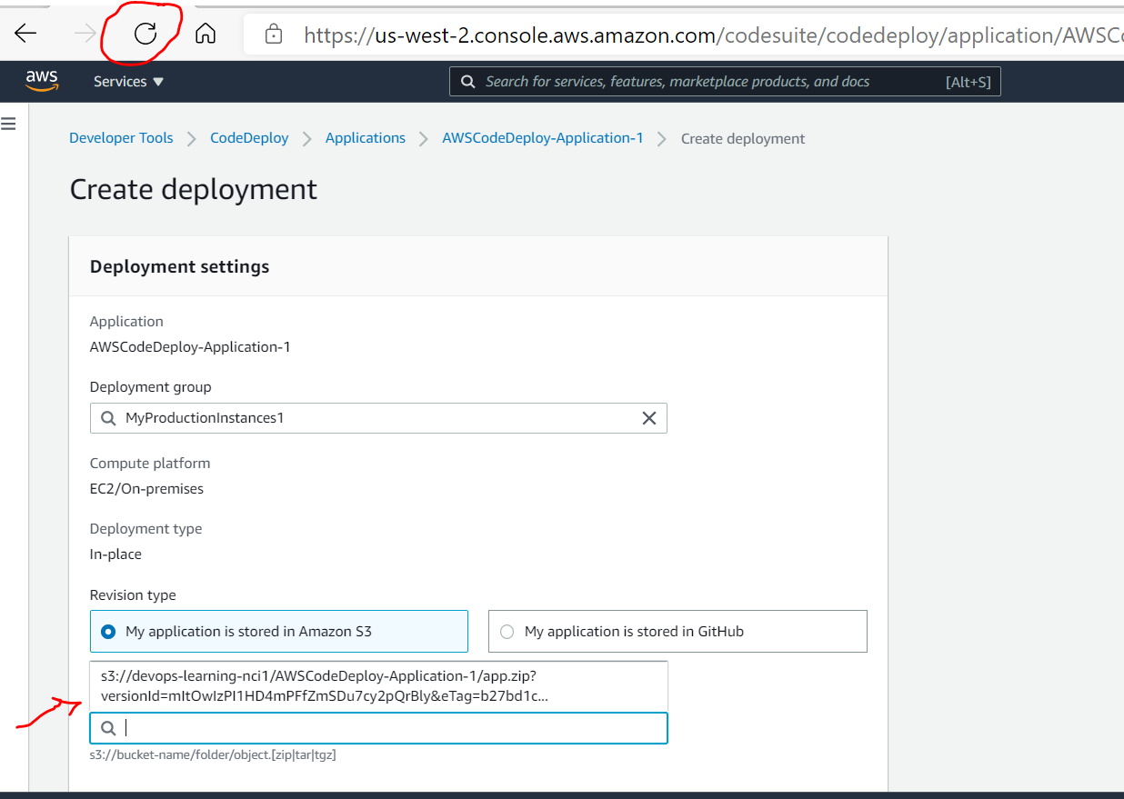

Select the S3 bucket and it’s latest version , where you uploaded S3 file in zip format.

**Note** : In below screen, you can **select “overwrite the content ”** if you are running code deploy on same EC2 instance otherwise during deploy you will get error that your files are already available at target location.

Click on Create Deployment and it will run the deployment automatically

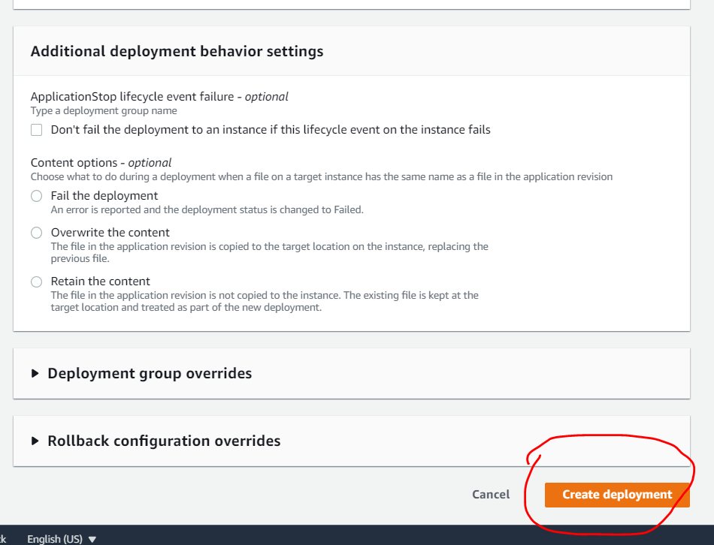

Check the status of your deployment

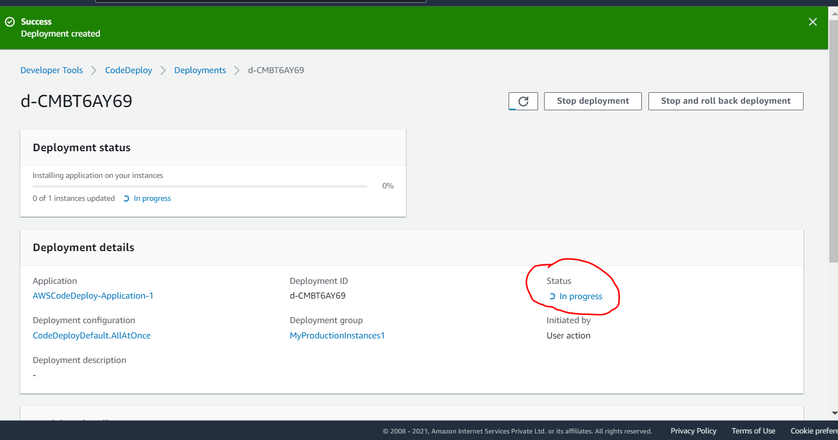

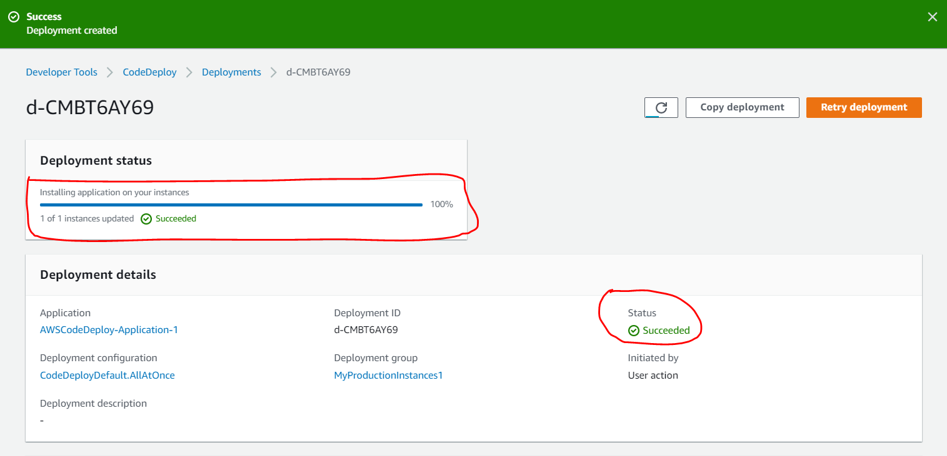

Check events , this will give you detail of appspec.yml hooks and stages , which it executed

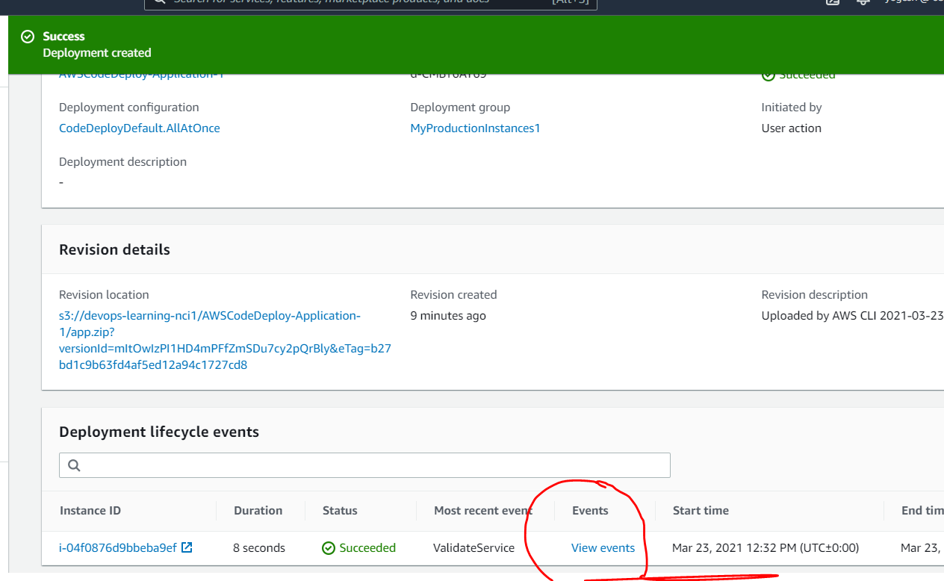

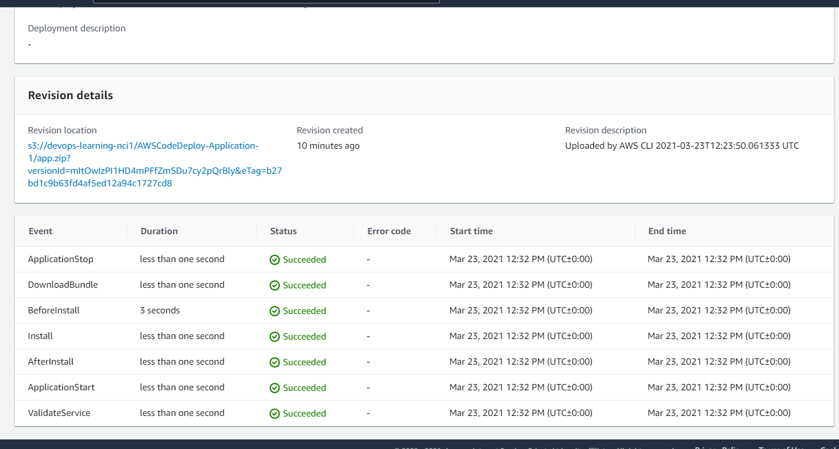

Now, access your application publicly

Go on your instance page in AWS and copy the public DNS name from there

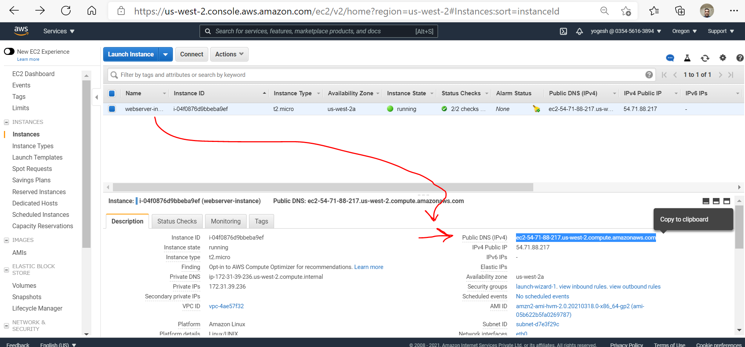

Paste this public DNS on browser and press enter you will see below page

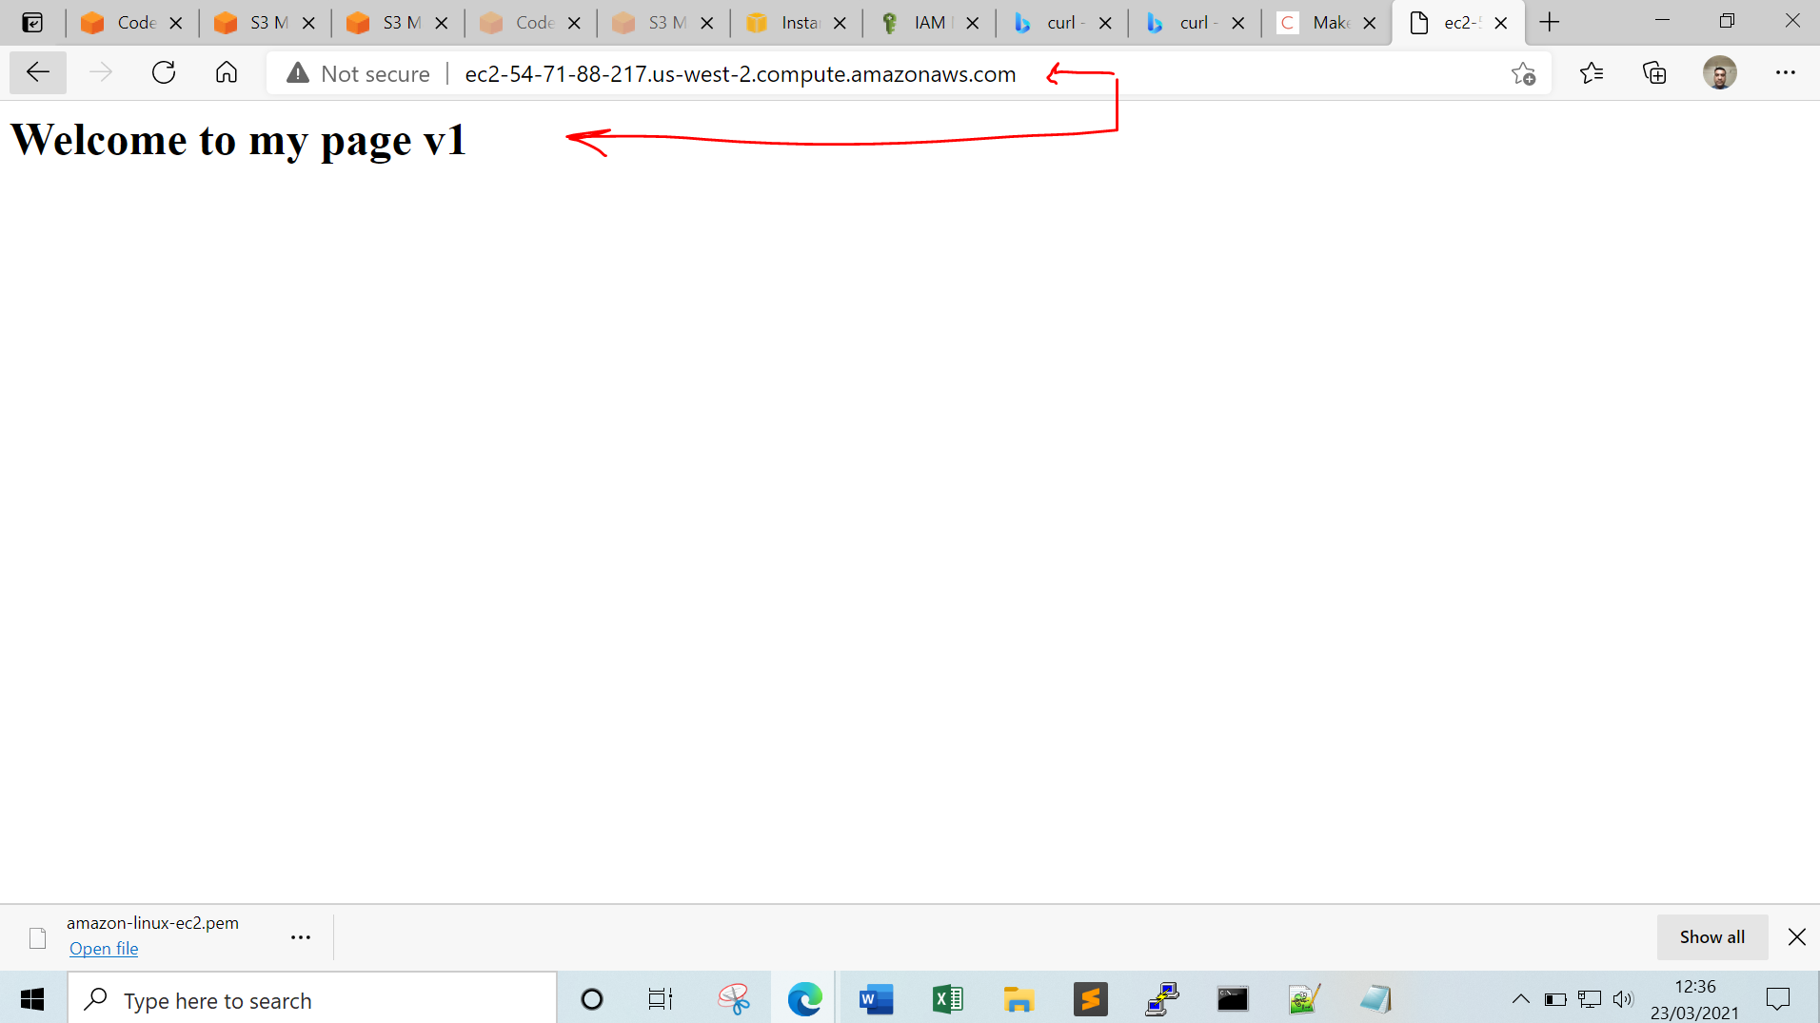

**Congratulations ☺**